Kurri Kurri Public School
Student Welfare and Discipline Policy and Pocedures 2020

Policy updated in 2020 in conjuction with the Department of Education Student Welfare Policy – PD 2002 0052 V01 and the NSW Department of Education Student Discipline Policy – PD 2006 0316 V03

Table of contents
Student Welfare Description
1: Policy statement

2: Audience and applicability

3: Context
4: Responsibilities and delegations
5: Monitoring, reviewing and reporting

Student Discipline Description
1: Policy statement

2: Audience and applicability

3: Context
4: Responsibilities and delegations
5: Monitoring, reviewing and reporting

Appendix

Appendix 1 – Counsellor Referral Forms Parents/ Carer and Class Teacher

Appendix 2 – Gold Awards

Appendix 3 – Kurri Kookies

Appendix 4 - NSW Department of Education Work Health and Safety (WHS) Policy

Appendix 5 – NSW Department of Education Bullying of students – Prevention and Response Policy

Appendix 6 – NSW Department of Education Suspension and Expulsion of School Students – Procedures

Appendix 7 – NSW Department of Education Behaviour Code for Students

Appendix 8 – Kurri Kurri PS Behaviour Flowchart

Appendix 9 – Kurri Kurri PS PBL Universal Settings Matrix

Student Welfare

Description

The New South Wales public education system seeks to provide quality education for all students, taking account of their age, background, ability and interests. Government schools help students to become self-directed, life-long learners who can create a positive future for themselves and for the wider community.

For this to occur, government schools need to be places where every student can learn and grow with confidence. Students develop best in schools where teaching and learning occur in a context of student welfare.

Schools need to be safe and happy places for students and their teachers. Student welfare is enhanced when all members of the school community participate in the learning programs and life of the school.

Kurri Kurri PS has developed their own student welfare policy and practices within the framework of the Student Welfare Policy, first introduced in 1986 and extensively revised to assist schools to build on existing good practice and to incorporate contemporary educational perspectives.

Kurri Kurri PS, as a school community, has consistently reviewed its Student Welfare policy, including discipline by:
- determining key issues for action.
- developing action plans relating to student welfare.
- implementing student welfare actions and the school discipline policy.
- reviewing student welfare within the school's ongoing planning and reporting processes.

- Policy Statement - Objectives

The Student Welfare Policy is a framework for school communities to review student welfare, determine key issues for action and develop and implement student welfare actions and initiatives.

Schools provide effective learning and teaching within secure, well-managed environments, in partnership with
parents/carers and the wider school community. The objectives and outcomes that follow therefore relate to:
- Effective learning and teaching.
- Positive climate and good discipline.
- Community participation.

- Effective Learning and Teaching

Kurri Kurri PS will enhance effective teaching and learning by:

A.1 encouraging students to take responsibility for their own learning and behaviour.
A.2 identifying and catering for the individual learning needs of students.

A.3 establishing well-managed teaching and learning environments.

A.4 ensuring that learning activities build on prior knowledge and experiences and are socially and culturally relevant.

A.5 providing frequent opportunities for students and their parents to discuss learning programs and student behaviour and progress.

A.6 identifying key social skills and developing plans for all students to acquire them, or make progress towards them, over time.

A.7 ensuring that gender and equity issues are recognised and addressed across the curriculum.

Outcomes:
- Students will be active participants in the learning process.
- Coordinated student services will provide effective support to classroom programs.
- The learning experiences of students will affirm their individuality and be positive and satisfying.
Results for students:
- Students will participate in decisions about their own learning.
- Students will pursue a program of learning relevant to their needs and aspirations.
- Students will develop an understanding of themselves as well as skills for positive, socially responsible participation.
- Students will develop competencies which enhance the quality of their relationships with others.
- Students will feel valued as learners.
- Positive climate and good discipline
Kurri Kurri PS will enhance school climate and discipline by:
B.1 maximising student participation in decision making and ensuring that principles of equity and fairness are reflected in school practice.
B.2 providing opportunities for students to demonstrate success in a wide range of activities.
B.3 developing and implementing policies and procedures to protect the rights, safety and health of all school community members.
B.4 establishing clear school rules which are known and understood by all school community members
B.5 monitoring attendance and ensuring that students attend school regularly.
B.6 valuing and providing opportunities for all students to develop the skills involved in positive relationships, social responsibility, problem solving and dispute resolution.
B.7 valuing difference and discouraging narrow and limiting gender stereotypes.
B.8 incorporating students’ views into planning related to school climate and organisation.
B.9 establishing networks to support students and making sure that students and parents know about, and have ready access to, this support.
B.10 recognising the relationship between student and staff welfare and ensuring that staff welfare is also a priority.
B.11 providing resources and opportunities for students to gain leadership experience using a range of mechanisms, including student representative councils or school parliaments.
B.12 Using positive feedback in the effective management of behaviour and acknowledging students who are consistently performing to the best of their ability across all areas in the school.

Outcomes:
- The well-being, safety and health of students and other community members will be priorities in all school policies, programs and practices.
- Principles of equity and justice will be evident in school plans, programs and procedures.
- The discipline code of the school will provide clear guidelines for behaviour which are known by staff, students and parents who have contributed to their development.
- The school will be a disciplined, ordered and cohesive community where individuals take responsibility and work together.
- The school will reflect the values of its community and will welcome the participation of community members in the life of the school.
- The school will be an inclusive environment which affirms diversity and respects difference.
Results for students:
Students will:
- be safe in the school environment.
- know what is expected of them and of others in the school community.
- be able to learn without disruption from unruly behaviour.
- be provided with appropriate support programs.
- contribute to decision making in the school.
- participate in all aspects of school life as equals.
- value difference.
- be respected and supported in all aspects of their schooling.
- know and understand their school’s organisation and know about student representative councils and other representative bodies such as the School Council.
- be supported and respected in all areas of their schooling.
- feel that their efforts are appreciated.
- develop a positive self-esteem.
- feel valued.
- make responsible choices.
- accept consequences for their behaviour.
- Community Participation
Kurri Kurri PS will enhance community participation by:
C.1 building learning communities in which staff, students and parents work together for planned results.
C.2 encouraging parents and community members to participate actively in the education of young people and in the life of the school.
C.3 acknowledging parents as partners in school education.
C.4 encouraging students to have a sense of belonging to the school community.
C.5 assisting families to gain access to support services in the community.
C.6 fostering close links with the wider community.
C.7 encouraging links between parent and student representative groups.
C.8 inviting parents to share their skills and experiences in the school community.
C.9 supporting students and their parents in making decisions about learning programs.
C.10 recognising students’ families, cultures, languages and life experiences.
Outcomes:
- There will be strong links between students, staff, parents and other members of the school community.
- Parents and community members will participate in the education of young people and share the responsibility for shaping appropriate student behaviour.
- The curriculum, goals, plans and actions of the school will reflect the needs and aspirations of students and the wider school community.
- Students, parents and teachers will perceive that the learning and teaching programs in the school are relevant and beneficial.
- Staff will facilitate parent and community involvement in a range of school activities.
Results for students:
- Students will be supported by parent and community participation in school activities.
- Students will value the school as an integral part of the community.
- Students and their families will know how to gain access to relevant support services in the community.
- Students will be partners with parents and teachers in the teaching and learning processes at the school.
2. Audience and Applicability
2.1
This policy applies to all members of the Kurri Kurri Public School community.

- Context

3.1
Student welfare at Kurri Kurri PS:

- encompasses everything the school community does to meet the personal, social and learning needs of students.
- creates a safe, caring school environment in which students are nurtured as they learn.
- is achieved through the total school curriculum and the way it is delivered.
- incorporates effective discipline.
- incorporates preventive health and social skills programs.
- stresses the value of collaborative early intervention when problems are identified.
- provides ongoing educational services to support students.
- recognises the diversity within the school community and provides programs and support which acknowledge difference and promote harmony.
- recognises the role that the school plays as a resource to link families with community support services.
- provides opportunities for students to:
- enjoy success and recognition.
- make a useful contribution to the life of the school.
- derive enjoyment from their learning.

- Responsibilities and delegations

4.1 Principal Responsibilities:

Principals will ensure that:
- a commitment to student welfare underpins all the policies and activities of the school.
- the school community reviews policies and practices related to student welfare.
- student welfare is regularly reviewed using appropriate planning processes.
- a school discipline policy is developed and regularly reviewed.
- the review processes take into account other mandatory policies.
- strategic issues identified in reviews are incorporated into the school plan.
- students, staff and parents are assisted to develop strategies for addressing student welfare and discipline needs in all the activities of the school.
- other policies and practices in the school are regularly reviewed to ensure that they meet the needs of all students in the school.

4.2 Staff Responsibilities

Teaching and support staff, according to their role in the school, will:

- ensure that they are familiar with the Student Welfare Policy and the School Discipline Policy.
- contribute to the provision of a caring, well-managed, safe environment for all students, fellow staff and parents.
- participate in the learning and teaching process in ways which take account of the objectives in this policy.
- participate in the school community’s implementation of the Student Welfare Policy.

Staff with a specific student support role will ensure that:

- Kurri Kurri PS develops effective mechanisms for integrating behaviour management, conflict resolution and support for students experiencing difficulties.

4.2.1 The Role of the School Counsellor

The counsellor’s role in school welfare is involved at two levels of responsibility; responsibility to the child as an individual and responsibility to the school as a whole.

The Counsellor:

- In promoting the interest of the child when necessary, acts as a mediator on the child’s behalf.
- is involved in a positive and supportive, rather than a punitive way. It is important that he or she be involved in the early identification and assessment of significant problems and ensure that appropriate steps are taken for prevention and/or remediation of these problems
- has a role that involves consultation with and giving advice to: parents, principal, teachers and pupils at all levels of schooling
- can contribute to the balanced development of the child since he/she is in a position to liaise with other agencies and resource personnel who have additional expertise and with whom communication would otherwise be difficult
- has an essential role in making contact with the child’s family and providing a link between the home and the school.
- is heavily involved in the placement and review of Special Education students.
- is involved in all Learning Support Teams for a child with special needs eg Funding Support, access to District support.

NB: Referrals to the school Counsellor are made through the Learning Support Team, parents or the principal (Appendix 1).

4.2.2 The Role of the Learning and support Teacher (LaST)

The Learning Support Teacher has a strategic role within the school to improve outcomes for students due to the diversity of learners and supports students with special education needs.

The Learning and Support Teacher’s role includes:

- Team teaching
- Consultation
- Support with intervention programs
- Resource development
- Individual assessments
- Referrals to other services through the Learning and Support Team (LST)

4.3 Student Responsibilities

Students will be encouraged to:

- act according to the discipline code established by the Kurri Kurri Public School community.
- contribute to the provision of a caring, safe environment for fellow students, staff and parents.
- participate actively in the learning and teaching process.
- provide their views on school community decisions, including reviews of student welfare, using agreed upon processes which include student representative councils and school parliaments.
- practise peaceful resolution of conflict.

4.4 Parent/Carer Responsibilities

Parents/carers will be encouraged to:

- participate in the learning of their children and the life of the school, including reviews of student welfare and the discipline code.
- share responsibility for shaping their children’s understanding about acceptable behaviour.
- work with teachers to establish fair and reasonable expectations of the school.

4.5 District and State Office Responsibilities

4.5.1 The Director Educational Leadership will ensure that:

- all staff are familiar with, and implement the Student Welfare Policy.
- the implementation of this policy is supported by district office staff.
- school programs support student welfare priorities and are responsive to the school community.

4.5.2 The Executive Director of School Performance will ensure that:

- all staff are familiar with the Student Welfare Policy.
- support generated in their directorate is consistent with this policy.
- all staff consider the implications of this policy.
- State Executive is provided with information on system-wide performance and policy advice in relation to student welfare.

- Implementation

5.1 Late Arrival/Early Departure Procedures

- Children may not leave during the day with anyone, including parents, without signing out at the front office. Any late arrivals need to report to the front office and be taken to their class.
- Parents are not to be in the school buildings without first reporting to the office and being given direction to do so by the front office.
- Children travelling by bus must go directly to their lines inside the grounds
- Children must travel to and from school by the most direct route or the designated Safe Route to School

5.2 Complaints
It is important for sound community relations that any complaint be handled thoroughly, fairly and expeditiously. Complaints will be dealt with under the DoE Complaints Handling Procedure.

  - Recognition of Student Achievement

At Kurri Kurri Public School the recognition of student achievement is an integral part of our Student Welfare Policy.

Outcomes for Students
Students will:
- be respected and supported in all aspects of their schooling.
- feel that their efforts are appreciated.
- develop a positive self esteem.
- feel valued.
- make responsible choices.
- accept the consequences of their behaviour.

School Award System
The Award System is an integral part of the Student Welfare program in the school.
Gold Awards need to be highly valued, and must be earned rather than readily available. It is designed to complement classroom reinforcement strategies, which may include stickers, stamps, lucky dips, praise etc. It is recommended that behaviour management systems be consistent across the grades.

The Structure
Gold Awards (Appendix 2) will be handed out at PBL assemblies. Every fortnight, each class will be awarded Gold Awards.
The awards will operate as follows:
Step 1: 5 Gold Cards = 1 Principal’s Award Name published in Newsletter.
Step 3: 5 Principal’s Awards = School Medallion Name published in Newsletter.
Gold Awards will carry over from year to year and be recorded by the classroom teacher on our Sentral program. Once recorded, they are stamped on the reverse side and returned to the student.
The Principal’s Award and School Medal will be presented at a K-6 Assembly by the Principal.

Kurri Kookies
Kookies (Appendix 3) can be handed out on the playground by ALL staff, including SLSO’s, admin, canteen, and visiting staff. These tokens are placed in a box and names are drawn out at the weekly PBL assemblies. Successful students (3 from K-2 and 4 from 3-6), Will be given an invitation to attend the Principals Lunch, held 3 times a term. This is not linked to the Gold Award, Principal Award and Medallion system in any way.

Assemblies
Students who achieve quality results in academic, sporting or cultural areas are recognised at school or stage assemblies and in the school newsletter.

6.Monitoring and review

6.1 Director, Educational Leadership Responsibilities

- The DEL will monitor the local implementation of the Student Welfare Policy

6.2 Principal Responsibilities:

- The Principal will monitor and implement the NSW Department of Education Student Welfare Policy and the Kurri Kurri PS Student Welfare policy within the school context.

6.3 Staff Responsibilities:

- The staff will implement the Kurri Kurri PS Student Welfare policy in line with NSW Department of Education guidelines.

Student Discipline

Description

Kurri Kurri Public School enters into mutually respectful relationships with parents, carers and school community members where a shared responsibility in regards to promoting positive student behavior, recognising and reinforcing student achievement and managing inappropriate behavior are a focus.

These partnerships aim to achieve effective learning and good discipline in a school environment that is respectful, productive and harmonious. They also encourage students to follow the NSW Public Schools Behaviour Code for Students and work towards students developing the ability to take responsibility for their own actions and behaviours.

1.Policy Statement – Objectives

1.1
Good discipline is fundamental to the achievement of the NSW Department of Education priorities for Kurri Kurri PS.
At Kurri Kurri PS we aim to:

- set and promote levels of acceptable behaviour
- lead pupils to understand that certain behaviour is unacceptable and why
- provide for positive reinforcement of acceptable behaviour
- ensure that where sanctions are necessary, they are administered fairly and consistently
- provide for student counselling within a strong student welfare context
- be consistent in attitude towards boys and girls
- ensure procedural fairness for all students
- provide opportunities for pupils to experience leadership and exercise responsibilities
- lead pupils through restorative practices
- lead pupils to recognise the need for positions of authority and to develop respect towards
those empowered to exercise authority
- cater for each student’s right to learn which depends on the capacity of teachers to carry out their
professional responsibilities in the classroom free from disruption.

2.Audience and applicability

2.1
This policy applies to all members of the Kurri Kurri Public School community.

3.Context

3.1

Kurri Kurri PS and their school community work together to provide a quality learning environment which is:

- inclusive
- safe and secure
- free from bullying, harassment, intimidation and victimisation.

3.2

All students and staff have the right to be treated fairly and with dignity in an environment free from disruption, intimidation, harassment, victimization and discrimination. To achieve this, Kurri Kurri PS maintains a high standard of discipline.

3.3

When parents enrol their children at public schools they enter into a partnership with the school. This partnership is based on a shared commitment to provide opportunities for students to take responsibility for their actions and to have a greater say in the nature and content of their learning. Collaboration between school staff, students and parent(s) or carer(s) is an important feature of discipline in government schools.

3.4

The aim of the partnership between school community members and schools is to develop socially responsible young people who are capable of making informed decisions. This is achieved through an effective social, cultural and academic curriculum which caters for the individual needs of students.

3.5
In implementing the school discipline policy, no student is to be discriminated against, harassed or victimised on any grounds as required by legislation.

3.6
This policy is to be implemented consistent with Work Health and Safety (WHS) Policy (Appendix 4) obligations for ensuring a safe and healthy working and learning environment for staff, students and visitors at schools.

3.7
Kurri Kurri PS has developed and implements an Anti-bullying Plan consistent with the Bullying of Students – Prevention and Response Policy (Appendix 5)

3.8
The school discipline policy may apply outside of school hours and off school premises where there is a clear and close connection between the school and the conduct of students.
4. Responsibilities and delegations

4.1 Principals

4.1.1
Principals are accountable through their Directors, Public Schools for ensuring a safe, secure and harmonious work environment for students and staff.

4.1.2
Principals are responsible for the development, implementation and monitoring of the school’s discipline policy.

4.1.3
Principals are responsible for ensuring that the school’s policy is evaluated and reviewed by the school community at least every three years.

4.1.4
Principals must ensure that students, staff and parent(s) and carer(s) are provided with opportunities to contribute to the development of the policy and that staff are provided with training and development opportunities in behaviour management.

4.1.5
Principals must provide a copy of their school discipline policy to their Directors, Public Schools when the policy is developed or whenever it is reviewed. A copy must also be made available to the families of children enrolled at the school.

4.1.6
Parents and students are to be given a copy of the discipline code or school rules when the policy is developed or whenever it is reviewed.

4.1.7
Principals must ensure that all disciplinary actions involving suspension or expulsion from school are managed consistent with the Suspension and Expulsion of School Students Procedures (Appendix 6).

4.2 Teachers

4.2.1
Teachers are expected to participate in the development of the school discipline policy and to support its effective implementation.

4.3 Parents

4.3.1
Parents are expected to support the school in the implementation of the school discipline policy.

4.4 Students

4.4.1
Students are expected to follow the Department of Education Behaviour Code for Students (Appendix 7)

4.4.2
Students are expected to follow the discipline code or school rules and to comply with staff directions regarding discipline and appropriate behaviour.

4.4.3
Students will show respect for teachers, fellow students, other staff and school visitors and not engage in any form of harassment, victimisation or intimidation.
4.4.4
Our Positive Behaviour for Learning (PBL) core values and student responsibilities are:
- Learning
- Respect
- Safety
5.Implementation
5.1
The school’s Discipline Policy promotes programs and practices which strengthen:
- Effective learning and teaching
- Positive climate and good discipline
- Community participation
At Kurri Kurri we believe that consequences should be clear, relevant and immediate. Students must be encouraged to take responsibility for their actions by making restitution whenever appropriate.
5.2 Classroom Expectations of Good Discipline and Self Discipline in our School
5.2.1 Discipline is best when all parties have clear expectations about the behaviours which are acceptable and a sense of comfort in their surroundings.
5.2.2 It is essential that all persons develop an awareness that they own, and are responsible for their behaviour. It is one of our aims to develop in all students a clear understanding of the ways in which their behaviour affects their ability to meet their various needs.
5.2.3 It is then equally essential that the owner of the behaviour understands the consequences which follow from their behaviour within the institutional and organisational context of the school, as this may be very different from the context in which they operate elsewhere.
5.2.4 Consistent inappropriate behaviour will result in referral of the problem and, if necessary, removal until an appropriate means of returning the child, with support structures in place, has been negotiated.
5.2.5 Referrals by teachers will be informal in the first instance to the supervisor and support sought for management strategies. Further action will be discussed with the relevant Assistant Principal and will be notified to parents.
5.3 Strategies
The following steps will be undertaken in the classroom:
1. Warning
2. Time out/Chill Out in classroom (K-2 only. 3-6 go from step 1 to step 3)
3. Time out with a buddy class – noted by class teacher. (This is for a period of 10 minutes).
4. Sent to Assistant Principal for time out. (This period will vary for each individual child and MAY be until the next break if the AP deems it necessary for all parties involved. The AP will discuss the behaviour with the child during the next Break period).
N.B: If a very serious misdemeanour occurs, the child may be referred straight to the Assistant Principal or Deputy Principal.

5.4 Playground Expectations of Good Discipline and Self Discipline in our playground.
Duty teachers are responsible to ensure the safety of students on the playground. They must be proactive in their responses and deal with situations as the need arises. Ways in which to be proactive include:
- Continual roving, interacting with children as you go
- Children who misbehave are spoken to and monitored
- Rewarding children who are positively behaving and issuing a Kurri Kookie
- Assisting isolated children to join in games
- Constantly monitoring out of bounds areas
5.5 Strategies
For minor behaviours the teacher is to use professional judgement and deal with the situation immediately. For example, by giving time out on the seat or restitution such as cleaning the mess they have made.
If a major behaviour has taken place, record the name of the child and the behaviour and refer it to the Assistant Principal at the end of duty or refer to the Deputy Principal immediately, as well as entering the incident on Sentral. The child is withdrawn from the playground and sat on the seat or asked to walk with the teacher for the rest of the duty.
5.6 Plan of Action for Teachers:
5.6.1 When confronted by students who exhibit minor or major behaviours, teachers should:
- Observe problem behaviour
- Decide whether the behaviour is Minor or Major.
- Follow the Kurri Kurri PS Behaviour Flowchart for Minor and Major Behaviour Responses (Appendix 8).
- prompt, redirect, reteach and provide choice for Minor behaviours.
- Allow students who are aggressive or upset to sit for a brief cooling off period prior to discussing a Major behaviour incident.
- Listen to ALL students involved to ascertain necessary information about the incident.
- Inform student/s of school Expectation violation and state expected behaviour by referring to the school’s PBL Universal Settings Matrix (Appendix 9).
- Decide on appropriate action (e.g time out).
- Communicate action to all involved, if appropriate.
5.6.2 If the playground teacher refers the incident on to the Assistant Principal, they will read the incident on Sentral, investigate further if necessary and issue an AP letter, phone call home and have these students with them off the playground the following break time. If it is of a more serious nature, the Deputy Principal and/or Principal will become involved and issue a DP letter or suspension if needed.
NB: If a misdemeanour is very serious, the child will be sent straight to the Assistant Principal or the Deputy Principal. If the child will not leave the area send for an appropriate executive.
5.7 Role of the Assistant Principal
5.7.1 Students are referred to the Assistant Principal if:
- A student has been dealt with by the classroom teacher or teacher on duty (including informal and formal contact with parents) and they continue to misbehave in the classroom and/or playground.
- A student has 3 repeated minor behaviours within 10 days and parents have been contacted.
- A PBL expectation violation has occurred and a major behaviour is entered on Sentral and the Assistant Principal is tagged.
5.7.2 The Assistant Principal will review the incident to determine a consequence.
5.7.3 The Assistant Principal will follow through with the consequence for an incident by:
- contacting the parent/carer.
- advising student, parent/carer and CT of student attendance at Structured Play for a period of 2 days or a period decided in consultation with parent, AP, DP and/or P.
- issuing an Assistant principal letter where necessary. The Assistant Principal’s letter will warn of possible suspension if further incidences of misbehaviour occur.
- finalising the incident on Sentral.
5.8 Role of the Deputy Principal
5.8.1 Students are referred to the Deputy Principal if:
- The Assistant Principal has reviewed an incident and deems it necessary for escalation to the Deputy Principal for further action.
- Behaviour is of a criminal nature and/or presents immediate risk to the safety of that student, other students and staff.
5.8.2 The Deputy Principal will:
- Provide timeout for students to calm down and begin to act in a rational manner after an incident.
- Supervise students who need time away from classroom and outdoor activities.
- Determine appropriate strategies to allow students to return to class.
- Allow all students involved in incidents the opportunity to have a voice and be heard.
- Contact student’s parents when incidents occur.
- Contact the School Counsellor, LaST Coordinator and/or Community Liaison Officer for additional student support where necessary.
- Issue a Deputy Principal letter where necessary.
- Refer students to the Principal and discuss course of action should their behaviour warrant a possible suspension.
- Follow NSW DoE Suspension and Expulsion guidelines when entering incidents on Student Administration ebs:central and when issuing paperwork to parent/carers for Suspensions
5.9 Role of the Principal
5.9.1 The Principal will:
- Review student behaviour, in line with the NSW DoE Suspension and Expulsion guidelines (Appendix 4), to determine whether a suspension is the appropriate course of action.
- Review student behaviour, in line with the NSW DoE Suspension and Expulsion guidelines, to determine whether a move to expulsion is the appropriate course of action.
- Follow NSW DoE Suspension and Expulsion guidelines when entering incidents on Student Administration ebs:central and when issuing paperwork to parent/carers for Suspensions

6.Monitoring and Review

6.1 Directors, Educational Leadership will monitor the local implementation of the NSW DoE Student Welfare and Discipline policy and will report to their Executive Directors, Public Schools.

6.2 The Principal will monitor the implementation of the NSW DoE policy and school’s Student Welfare and Discipline policy and will report to the Director, Educational Leadership on all matters related to the policy.

6.3 The staff will implement the Kurri Kurri PS Student Welfare and Discipline policy in line with NSW Department of Education guidelines.

Appendix

Appendix 1 – Counsellor Referral Forms Parents/ Carer and Class Teacher

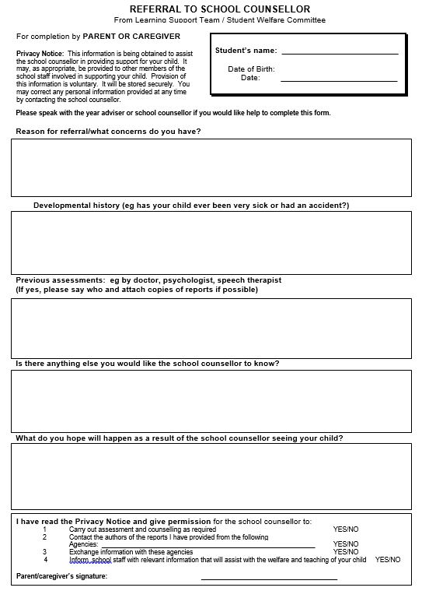

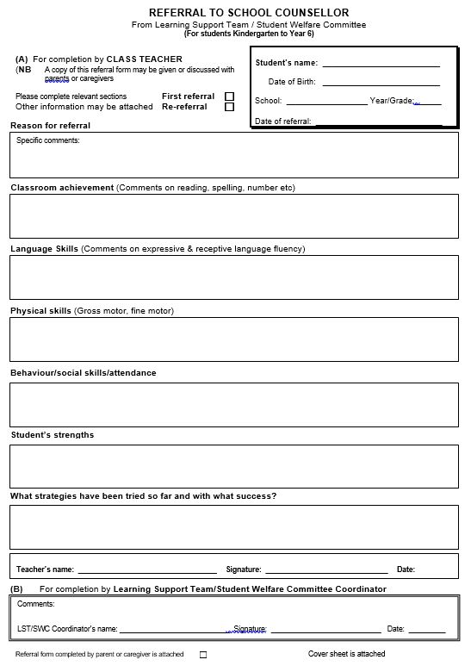

Appendix 2 – Gold Awards

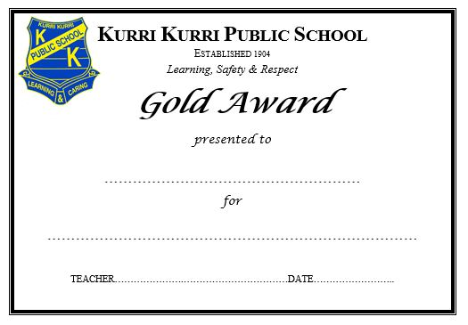

Appendix 3 – Kurri Kookies

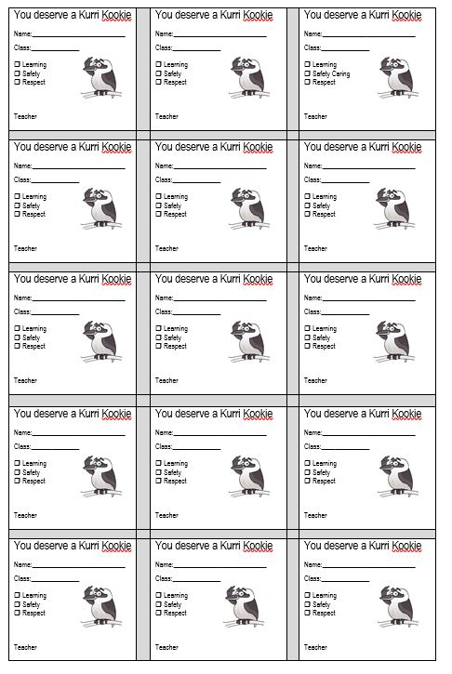

Appendix 4 - NSW Department of Education Work Health and Safety (WHS) Policy

https://policies.education.nsw.gov.au/policy-library/policies/work-health-and-safety-whs-policy

Appendix 5 – NSW Department of Education Bullying of students – Prevention and Response Policy

https://policies.education.nsw.gov.au/policy-library/policies/bullying-of-students-prevention-and-response-policy

Appendix 6 – NSW Department of Education Suspension and Expulsion of School Students – Procedures

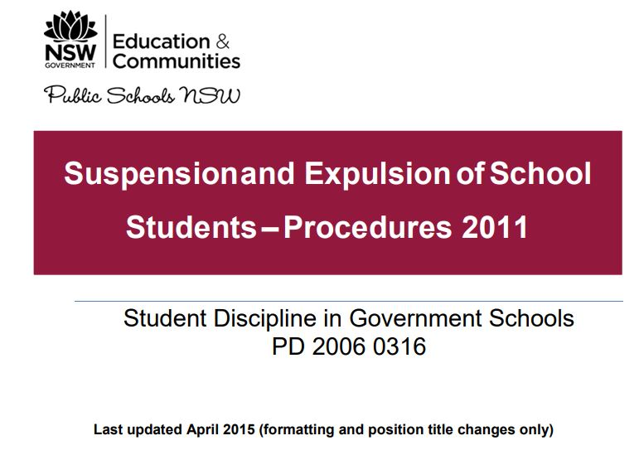

https://policies.education.nsw.gov.au/policy-library/associated-documents/suspol_07.pdf

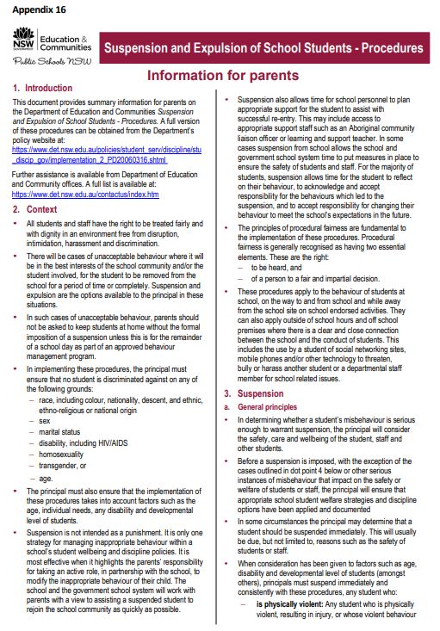
https://policies.education.nsw.gov.au/policy-library/associated-documents/leaflet_1.pdf

Appendix 7 – NSW Department of Education Behaviour Code for Students

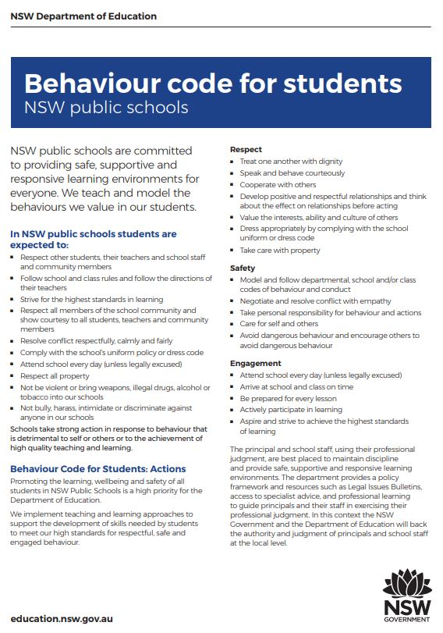

https://policies.education.nsw.gov.au/policy-library/associated-documents/behaviourcode.pdf

Appendix 8 – Kurri Kurri PS Behaviour Flowchart

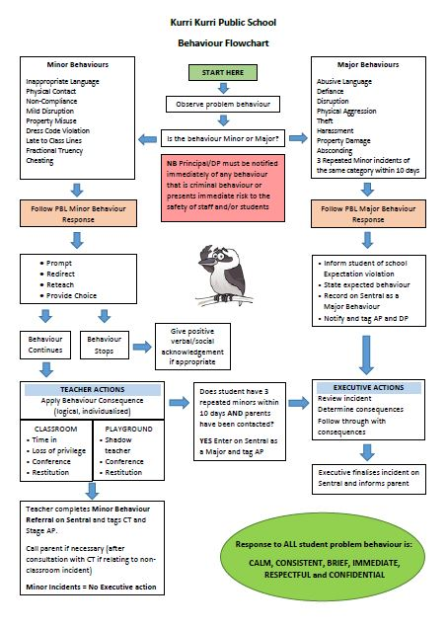

Appendix 9 – Kurri Kurri PS PBL Universal Settings Matrix

